Sprint 1 Plan
Project Name: Tutor Trade
Group Name: Slug Tutors
Sprint Completion Date: 7/7/2019
Revision Number: 3
Revision Date: 6/29/2019

Goal: The main goal for this first Sprint is to create basic versions of the Landing Page, Profile Creation Page, and the Home Page.

Task Listings:

User Story 1: As a student, I want a fast and efficient login process because I am constantly short on time.

Task 1 Description: Create landing page (2 hrs)
Task 2 Description: Signup page (2 hrs)

User Story 2: As a student, I want a profile creation feature to sign in for tutoring services because being able to list my tutoring abilities as well as my tutoring needs.

Task 4 Description: Store profile in database (8 hrs)
Task 5 Description: Create input fields for profile entry. (2 hrs)

User Story 3: As a student, I want to be able to browse listings or profiles.

Task 6 Description: Create bulletin board page. (2 hrs)
Task 7 Description: Connect bulletin board and database. (8 hrs)
Task 8 Description: Create acceptance / notification system. (8 hrs)

Team Roles:

Cris Castillo: Product Owner/Developer

Kisoo Kim: Developer

Dayeon Kim: Developer

Brian Alegria: Developer

Joshua Rony: Scrum Master/Developer

Initial Task Assignment:

Cris Castillo: Homepage

Joshua Rony: Homepage

Kisoo Kim: Profile Creation Page

Dayeon Kim: Profile Creation Page

Brian Alegria: Landing Page

Revised Burnup Chart (Day 2):

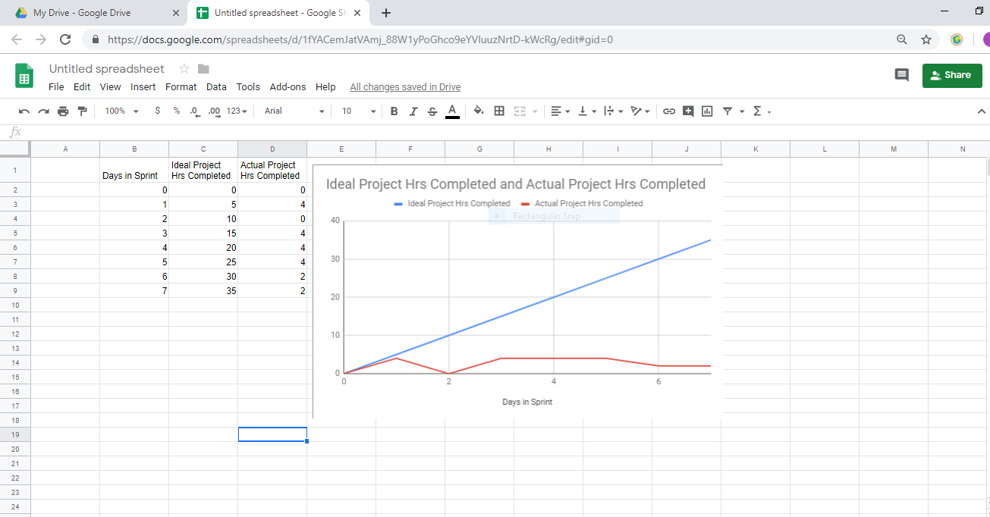

Day 3 scrum Board:

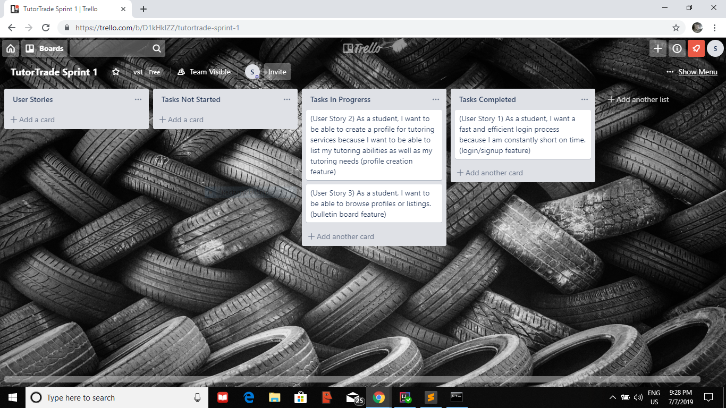

Scrum Times:

Weekly Scrum Meeting 1: Monday @ 4:00 – 7:00 pm
Weekly Scrum Meeting 2: Wednesday @ 4:30 – 7:00 pm
Weekly Scrum Meeting 3: Thursday @ 4:00 – 4:45 pm

